[LAB] Tester Zoyi ZT219
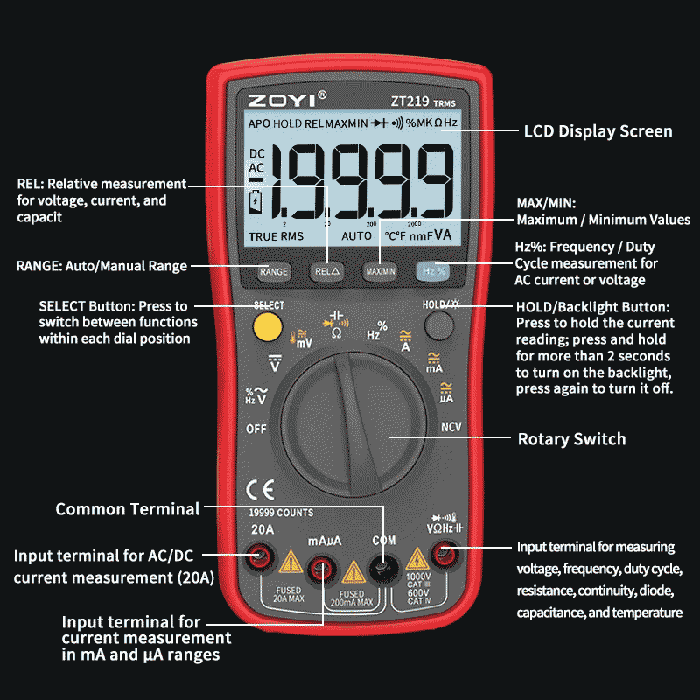

- Manual

Especificación | Rango | Precisión
Voltaje DC | 19.999mV/199.99mV/1.9999V/19.999V/199.99V/1000V | ±(0.05%+3)
Voltaje AC | 19.999mV/199.99mV/1.9999V/19.999V/199.99V/750V | ±(0.3%+3)
Corriente DC | 199.99μA/1999.9μA | ±(0.5%+3)
19.999mA/199.99mA/1.9999A/19.999A | ±(0.5%+3) | 19.999mA/199.99mA/1.9999A/19.999A
Corriente AC | 199.99μA/1999.9μA | ±(0.8%+3)
19.999mA/199.99mA/1.9999A/19.999A | ±(0.8%+3) | 19.999mA/199.99mA/1.9999A/19.999A
Resistencia | 1.9999kΩ/19.999kΩ/199.99kΩ | ±(0.5%+5)
999.9Ω/9.999kΩ/99.99kΩ/999.9kΩ | ±(0.2%+3) | 999.9Ω/9.999kΩ/99.99kΩ/999.9kΩ
1.9999MΩ/19.999MΩ | ±(1.0%+3) | 1.9999MΩ/19.999MΩ
199.99MΩ | ±(5.0%+5) | 199.99MΩ
Capacitancia | 9.999nF | ±(5.0%+20)
99.99nF/999.9nF/9.999μF/99.99μF/999.9μF | ±(2.0%+5) | 99.99nF/999.9nF/9.999μF/99.99μF/999.9μF
9.999mF | ±(5.0%+5) | 9.999mF
Frecuencia | 99.99Hz/999.9Hz/9.999kHz/99.99kHz | ±(0.1%+2)
/999.9kHz/9.999MHz | ±(0.1%+2) | /999.9kHz/9.999MHz
Duty Cycle | 1%-99% | ±(0.1%+2)
Temperatura | -20℃~1000℃/-4℉~1832℉ | ±(2.5%+5)

